1. **Introduction**

The Project Plan outlines Bulldogs Racing’s goals for the 2016 competition cycle and lists strategies that Bulldogs Racing will employ to ensure that the stated goals are met. This information is presented in four sections titled Background, Scope, Structure, and Schedule.

1. **Background**

**2.1 Bulldogs Racing**

Bulldogs Racing (BR) is a small engineering team that designs, fabricates, and tests Formula SAE style vehicles. In previous years, the team has competed with hybrid vehicles in Formula SAE Hybrid. This year, BR will break from the past and design and race an electric vehicle. This choice was made out of a desire to understand and implement the new EV technologies emerging in the automotive market and to race at more competitions. The car built for 2016 will be taken to Formula SAE Hybrid, Formula North, and Formula SAE Electric. This document will focus on the relation between BR and Formula Hybrid.

**2.2 Problem Statement - Formula SAE Hybrid**

Formula SAE Hybrid is an engineering competition that requires students to design, fabricate, and tune Formula SAE vehicles. At the competition, teams compete in events that test the vehicle’s dynamic and static capabilities and that evaluate the management and design of the vehicle.

1. **Scope**

**3.1 Goal**

Members of BR will design, build, and tune an electric Formula SAE vehicle that will compete and win Formula SAE Hybrid, Formula North, and Formula SAE Electric. The vehicle will be durable, able to compete in three competitions without major repair, and powerful, competitive at all three competitions. The vehicle will be ready for dynamic testing by February 14th. By April 25thm it will be tuned and ready to race.

**3.2 Objectives**

BR has two objectives, listed below in order of importance, that direct the team’s actions.

**3.2.1 Realizable**

Designers will create realizable designs that strive for simplicity, durability, and serviceability over lavishness. Fabricators will receive these designs and construct to the tolerance specified to ensure that parts are produced on time with the acceptable level of precision. The success of the vehicle will be evaluated by its completion on time and by its ability to complete three competitions without requiring major repair.

**3.2.2 Competitive**

BR will purchase and design around two Emrax 207 Medium Voltage electric motors and 86 A123 Lithium Iron pouch cells, creating the most competitive battery-motor combination available. The battery will provide a voltage of 284V and a peak current of 600A. This output will provide a max torque of 140 Nm and a max rotational speed of 6000 rpm. When coupled with a 4:1 planetary gearbox, these figures translate into a max top speed of 150 kph and an acceleration over 1g.

**3.3 Deliverables**

A tuned FSAE vehicle with supporting design and project management documentation will be completed by April 25th, 2016.

**3.4 Milestones**

Milestones are shown in the Gantt chart (figure 2). A full list can be found in appendix 1.

**3.5 Expected Results and Measures of Success**

An FSAE vehicle built in accordance to the objectives will be completed on time vis-à-vis the Project Plan. Accordingly, t*he vehicle will have a 0-100 kph time of 2.6 seconds, a 75-meter time of 3.2 seconds*, an efficiency of 80%, and the ability to finish a 44 km endurance course at an average speed of 48 kph. The vehicle and project will be deemed successful if they first meet the project deadline with the desired quality and second, achieve the stated expected results.

1. **Structure**

**4.1 Work Breakdown Structure**

From an examination of the problem statement and goals, it is possible to segment the project into a work breakdown structure (WBS). This structure is illustrated below.

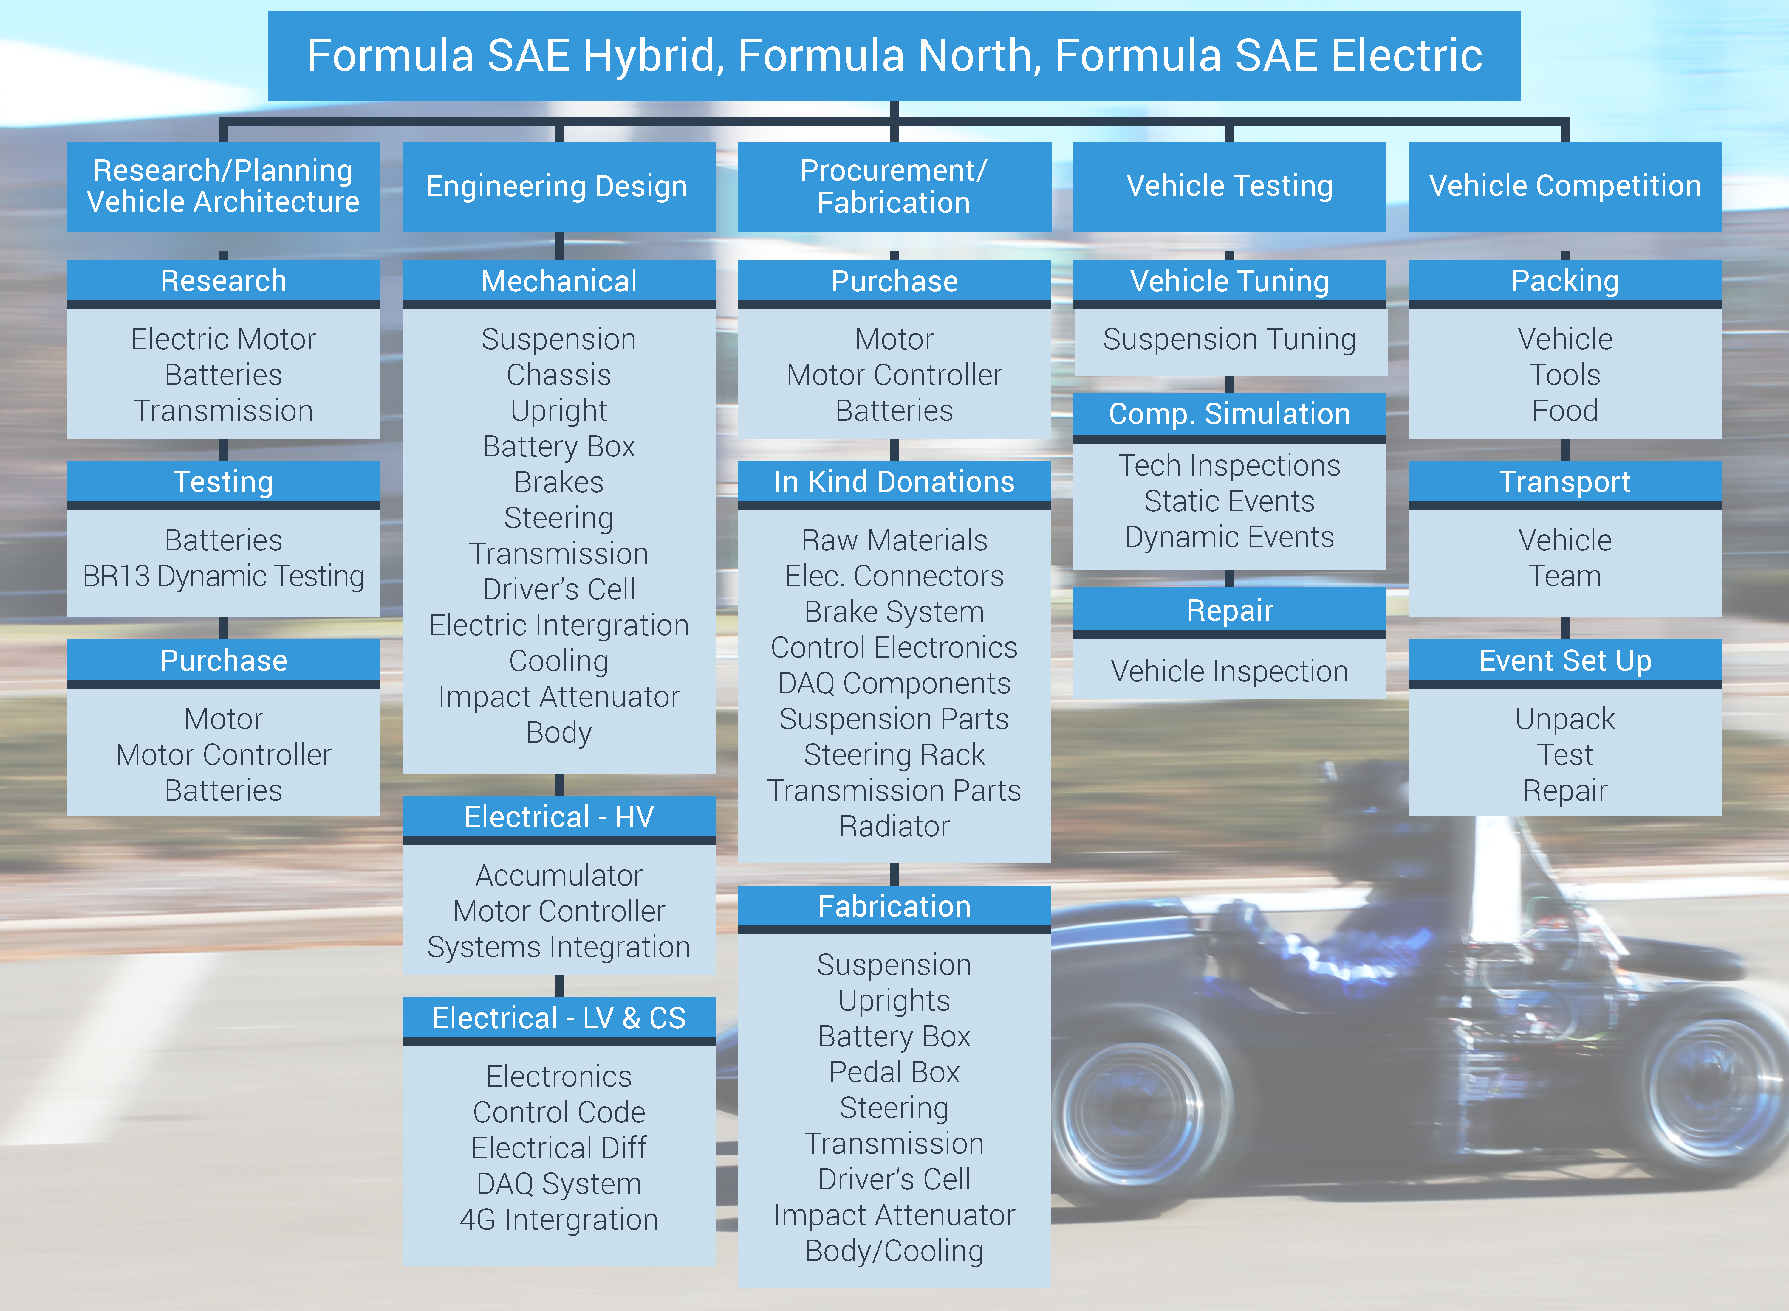

Figure 1: Work Breakdown Structure

**4.2 Team structure**

Using the WBS as a guide, BR is split into a series of divisions, each tasked with accomplishing one aspect of the project. The first division, Leadership, is responsible for describing the vision of the team and communication between the team and administration. The second division, Business, focuses on managing and securing funding and in kind donations. *This division is further broken into two sub-teams, Fincance and Media. The Finance team searches and secures funding and purchases material and components. The Media team manages the webpage and monthly newsletter and creates promotional media.* The final division, Engineering, is tasked with designing and fabricating the vehicle. Since design and fabrication is the most time consuming portion of the project, the structure of the Engineering Division is further designed.

The Engineering Team is led by a Chief Engineer and supported by a Project Manager. Together, the two determine the subtasks and associated work packages (see appendix 2) that must be designed. These work packages are assigned to project teams. Once the package is completed, the members of the project team are reassigned to a new task.

**4.3 Succession Plan**

To promote team growth and continuity between years and build cycles, the Leadership Division has created a succession plan that focuses on retention of engineering and leadership institutional knowledge. Engineering knowledge will be stored using two main functions, a series of design revisions housed on an SVN repository available to all team members, and design reports (appendix 3) that describes the process to complete the work package. These design reports, along with similar leadership handbooks and engineering standards adopted by BR are stored on the SVN repository in a digital library. This system will create and store the collective knowledge of BR.

1. **Schedule**

***5.1 Gantt Chart***

A list of project activity parameters (appendix 4) was constructed from the WBS and work packages. These parameters were used to create a Gantt chart that includes project timeline and critical path. A shortened version of the chart is below (full chart appendix 5).

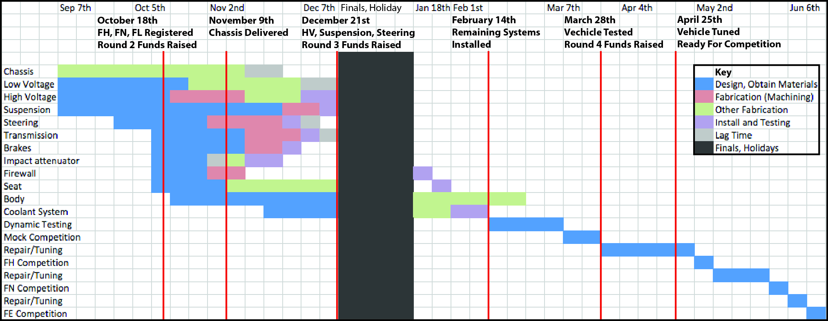

Figure 2: Gantt Chart

**5.2 Change Management Process**

When a project team assigned a work package realizes that they will overrun their current schedule, they submit a change request form (appendix 6) that states the cause of the delay, any potential fix that might right the delay, and a request for an extension if one is needed. The project manager reviews this document and, if a change to the project schedule is required, meets with the affected parties with the aim to find a solution that satisfies everyone. After this meeting, the project manager issues an updated project schedule.

**6. Appendix**

**6.1 List of Milestones**

Vehicle architecture defined 6/1

Chassis design finished 7/1

Chassis Work Order finalized 8/3

Round 1 Fundraising Goals met 8/3

Register for Formula Hybrid 10/18

Round 2 fundraising Goals met 10/18

Project Plan Finalized 11/4

*Chassis delivered 12/7*

*HV, Suspension, Steering Systems installed 3/1*

Round 3 fundraising goals met 12/21

*Remaining systems installed 3/14*

*Vehicle moves under own power 3/20*

*Vehicle completes mock competition 3/30*

Round 4 fundraising goals met 3/28

Vehicle is tuned and ready to race 4/25

**6.2 Example of Work Package**

**Macintosh HD:Users:micoarchangeli:Desktop:Transmission - WP.pdf**

**6.3 Outline of Design Report**

**Macintosh HD:Users:micoarchangeli:Desktop:Design Report Outline.pdf**

**6.4 Project Activity ParametersMacintosh HD:Users:micoarchangeli:Desktop:Project Activity Parameters Sheet1.pdf**

**6.5 Full Gantt Chart**

**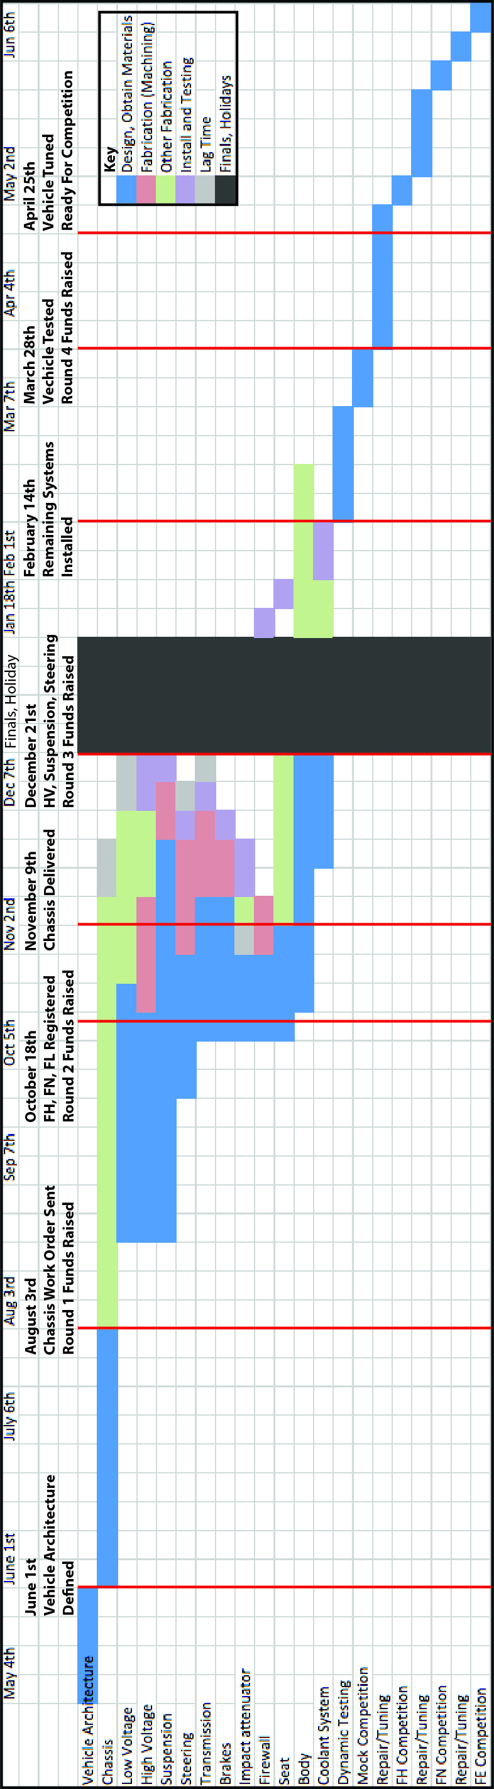**

**6.6 Change Request Form**

**Macintosh HD:Users:micoarchangeli:Desktop:Chassis_Oct_20 - CRF.pdf**